

July 31, 2014

Re: NPA 959 to Overlay NPA 860 (Connecticut)

Dear Customer,
In the Decision dated September 22, 1999, in Docket No. 96-11-10RE1 DPUC Review of Management of Telephone Numbering Resources in Connecticut, the Public Utilities Regulatory Authority ordered in part, that the 959 area code be overlaid on the existing 860 numbering plan area (NPA). A map depicting the area to be served by the 860 and 959 NPAs is attached.

Implementation of Relief Plan
Implementation of the overlay of the 959 NPA is as follows:

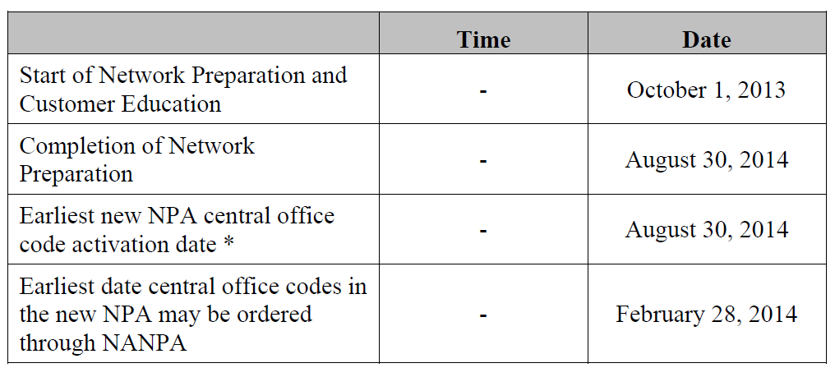
* Effective Date of the New 959 NPA

In accordance with industry consensus, all network preparation for the implementation of the 959 NPA should be completed by August 30, 2014. Since ten-digit dialing is already mandatory in the area served by these codes, no permissive dialing period is required in preparation for this overlay.

Dialing Plan

The dialing plan for the 860 and 959 NPAs will be as follows:

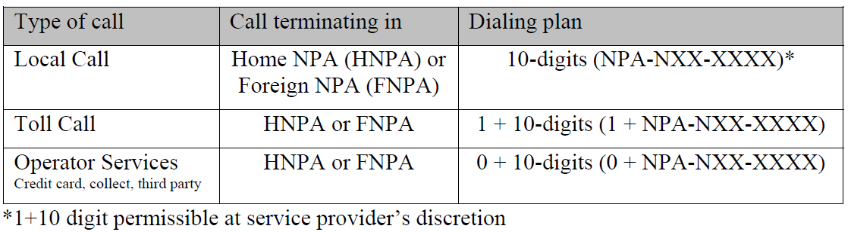

To prepare for this overlay, please note the following:

- Notify your clients, vendors, domestic and international of your new area code.
- Inform employees, customers, and co-workers.
- Changes in telephone equipment should be directed to the equipment vendor.
- Utilize the applicable test number to make sure your equipment recognizes the new area code.
- Update all correspondence, such as stationery, business cards, checks, brochures, promotional items, internet web pages, catalogs, directory listings.
- Reprogram features such as Auto-Dialing, Speed dialing, and Call Forwarding.
- Reprogram security doors and gate systems.
- Contact your service provider to update your cell phone and other wireless communications.
- Internet dial-up connection may need reprogramming or upgraded.
- Notify Alarm system providers of the new area code + telephone number so they can update their records and equipment as needed.

The area code overlay will not affect the cost of a call. Costs incurred for updating systems and revising printed materials is the responsibility of the customer. The directory listings (white pages) will be updated by the telecommunications industry. Listings appearing in other directories will be the responsibility of the customer.

If you have any additional questions, please contact your Premier Specialist or Customer Service 1-866-847-5500.

